**sNumber of the Experiment :** 08

**Name of the Experiment :** Implementation of SJF algorithm with a C program.

**Date of Performance :**

**Date of Submission :**

**Aim and Objectives :** To learn about SJF or Shortest Job First Algorithm and implement it using C program.

**Theory :** Shortest Job First Scheduling works on the process with the shortest burst time or duration first.

* This is the best approach to minimize waiting time.
* This is used in Batch Systems.
* It is of two types:

1. Non pre-emptive.
2. Pre-emptive.

* To successfully implement it, the burst time/duration time of the processes should be known to the processor in advance, which is practically not feasible all the time.
* This scheduling algorithm is optimal if all the jobs/processes are available at the same time. (either Arrival time is 0 for all, or Arrival time is same for all).

**Source Code :**

#include<stdio.h>

void main()

{

int bt[20],p[20],wt[20],tat[20],i,j,n,total=0,pos,temp;

float avg_wt,avg_tat;

printf("Enter number of process:");

scanf("%d",&n);

printf("\nEnter Burst Time:\n");

for(i=0; i<n; i++)

{

printf("p%d:",i+1);

scanf("%d",&bt[i]);

p[i]=i+1; //contains process number

}

//sorting burst time in ascending order using selection sort

for(i=0; i<n; i++)

{

pos=i;

for(j=i+1; j<n; j++)

{

if(bt[j]<bt[pos])

pos=j;

}

temp=bt[i];

bt[i]=bt[pos];

bt[pos]=temp;

temp=p[i];

p[i]=p[pos];

p[pos]=temp;

}

wt[0]=0; //waiting time for first process will be zero

//calculate waiting time

for(i=1; i<n; i++)

{

wt[i]=0;

for(j=0; j<i; j++)

wt[i]+=bt[j];

total+=wt[i];

}

avg_wt=(float)total/n; //average waiting time

total=0;

printf("\nProcess\t Burst Time \tWaiting Time\tTurnaround Time");

for(i=0; i<n; i++)

{

tat[i]=bt[i]+wt[i]; //calculate turnaround time

total+=tat[i];

printf("\np%d\t\t %d\t\t %d\t\t\t%d",p[i],bt[i],wt[i],tat[i]);

}

avg_tat=(float)total/n; //average turnaround time

printf("\n\nAverage Waiting Time=%f",avg_wt);

printf("\nAverage Turnaround Time=%f\n",avg_tat);

}

**Output :**

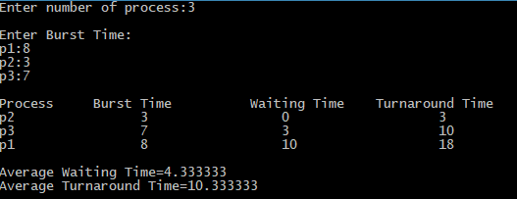

**Discussion :**

Shortest job first (SJF) or shortest job next, is a scheduling policy that selects the waiting process with the smallest execution time to execute next. SJN is a non-preemptive algorithm